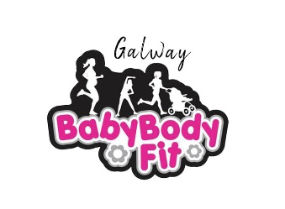
Gym On Wheels

Frequency | Pay Per | Type | Price | Discount | Type | Price | Discount | Type | Price | Discount
Once per week | Single | 1-1  training | €55 each per session |  | 2 clients small group training | €45 each per hour |  | 3 clients small group training | €35 each per hour
Twice per week | Single | 1-1 training | €50 per hour/€100 per week | €5 per hour/€10 per week | 2 clients small group training | €40 each per hour/€80 each per week | €5 each per hour/€10 each per week | 3 clients small group training | €30 each per hour/€60 each per week | €5 each per hour/€10 each per week
Once per week | Block of 5 sessions over 5 weeks | 1-1 training | €250 | €25 discount | 2 clients small group training | €200 each | €25 discount each | 3 clients small group training | €150 each | €25 discount  each
Once per week | Block of 10 sessions over 10 weeks | 1-1 training | €500 | €50 discount | 2 clients small group training | €400 each | €50  discount each | 3 clients small group training | €300 each | €50 discount each
Twice per week | Block of 6 sessions over 3 weeks | 1-1 training | €260 | €40 discount | 2 clients small group training | €200 each | €40 discount each | 3 clients small group training | €140 each | €40 discount each
Twice per week | Block of 10 sessions over 5 weeks | 1-1 training | €450 | €50 discount | 2 clients small group training | €350 each | €50 discount each | 3 clients small group training | €250 each | €50 discount each

